Final Assessment-Alternative Assessment
Semester | 202520 | Division | CIS
Assessment title in Syllabus | Final_Project_Portfolio | Program | Bachelor of Information Technology/ Bachelor of Information Systems
Course Code | CDS 2413
Course Title | INTRODUCTION TO DATA SCIENCE
Course Instructor |  | CRN
Assessment | Project Deliverable 3 – Data Versioning Report | Submission Date | Week 15
Student Declaration:
Academic Integrity Statement
In accordance with the HCT Academic Integrity Policy
• Students are required to refrain from all forms of academic integrity breaches as defined and explained by HCT.
• A student found guilty of having committed acts of academic integrity breach(es) will be subject to the relevant sanctions as outlined by HCT.
إفادة النزاهة الأكاديمية
وفقًا لسياسة كليات التقنية العليا للنزاهة الأكاديمية
• على الطلبة الإلتزام بلوائح وقواعد النزاهة الأكاديمية، كما هو مبيّن وموضح في السياسات والإجراءات الخاصة بكليات التقنية العليا.
• في حالة ارتكاب الطالب أي شكل من أشكال الإخلال بالنزاهة الأكاديمية، سيتعرض الى العقوبات الموضحة في السياسات ذات الصلة.
This assignment is entirely my/our own work except where I have duly acknowledged other sources in the text and listed those sources at the end of the assignment. I have not previously submitted this work to the HCT, or any other entity. I understand that I may be orally examined on my submission.

Student HCT ID(s): | H00 | H00 | H00 | H00
Student Name(s):
Student Signature
Chatbot (e.g. ChatGPT) statement
This submission allows you to use AI generated tools, but the prompt used must be stated and the response must be in red font. Include References to ChatGPT.

Instructions

Data Versioning(10 Points)
This CLO assesses the group’s ability to use version control to manage, synchronise, and update project files collaboratively using GitHub.

1. Creating a Repository (1 Point)

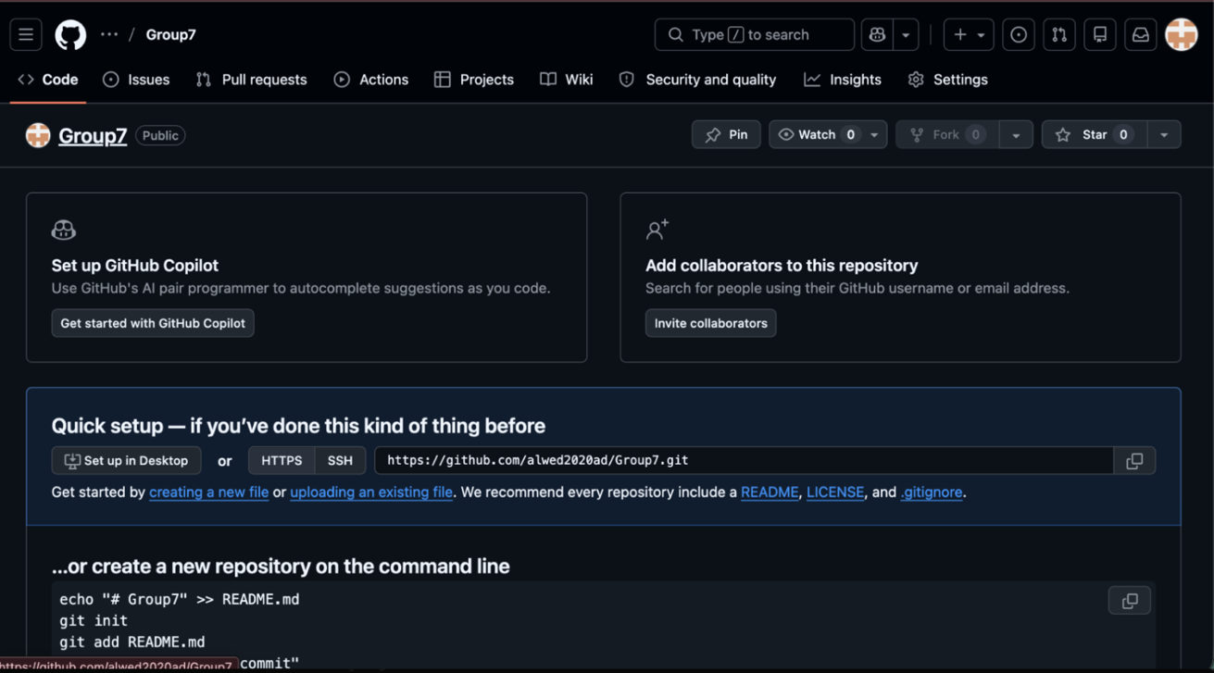

Out in the open, a fresh GitHub spot called Group7 now holds every file tied to the project. Holding everything together, it gives the team a single location for documents while tracking changes as work moves forward.

2. Uploading Project Files (1 Point)

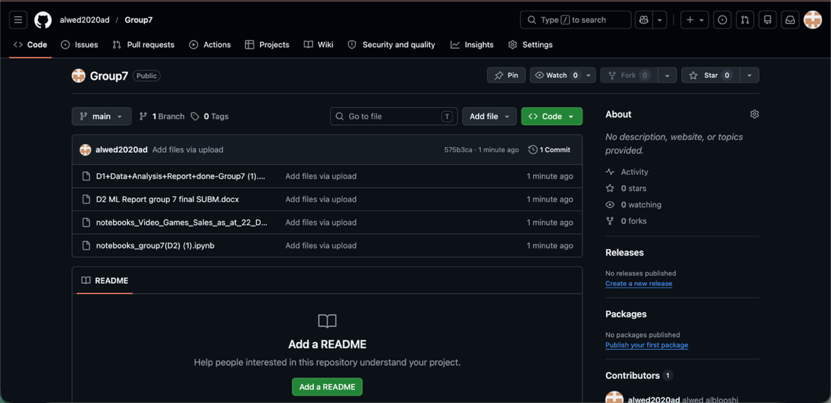

Files for the project now live on GitHub - reports, notebooks, everything needed sits together. With these in place, teammates reach what they need without hunting through scattered folders. Organization sticks when materials stay in one predictable spot.

3. Local Repository Setup (2 Points)

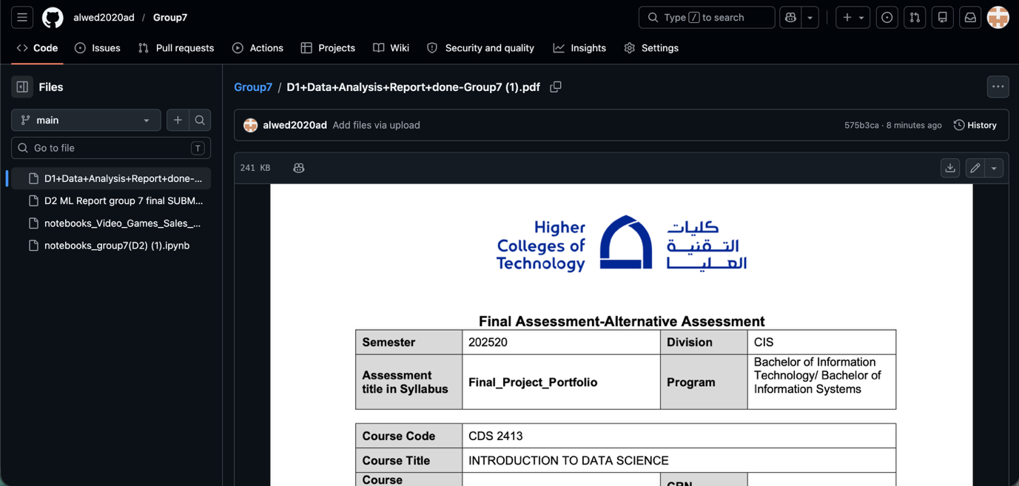

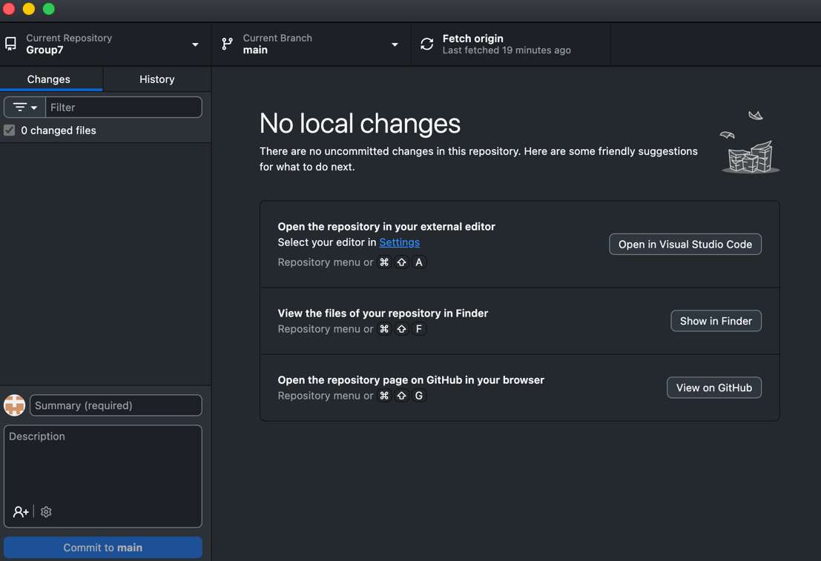

A folder appeared on the computer, pulled down by GitHub Desktop. Working without internet became possible since edits stayed saved nearby. Changes moved smoothly between people because each person kept a full copy close at hand.

4. Cloning the Repository (2 Points)
The GitHub repository is cloned locally to allow collaborative development and file versioning.

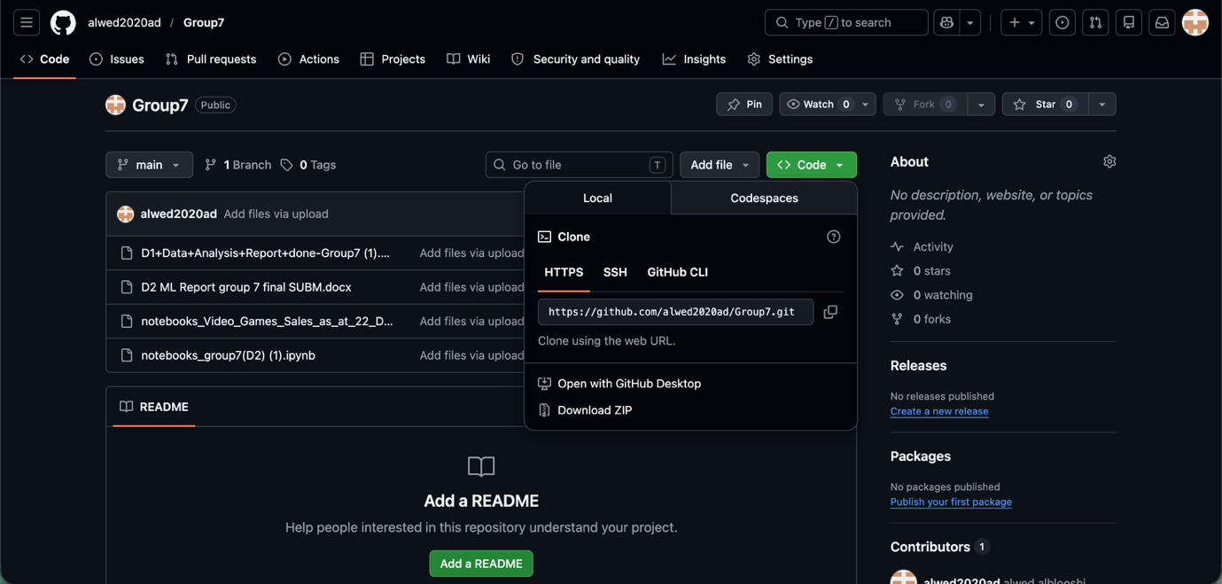

A fresh version landed on the machine after grabbing it straight from GitHub by pasting the web link. That local setup opened doors - teammates started adjusting code, swapping notes, pulling updates without roadblocks.

5. Synchronising Changes (2 Points)
Updates from the remote GitHub repository are retrieved to ensure the local repository remains up to date.

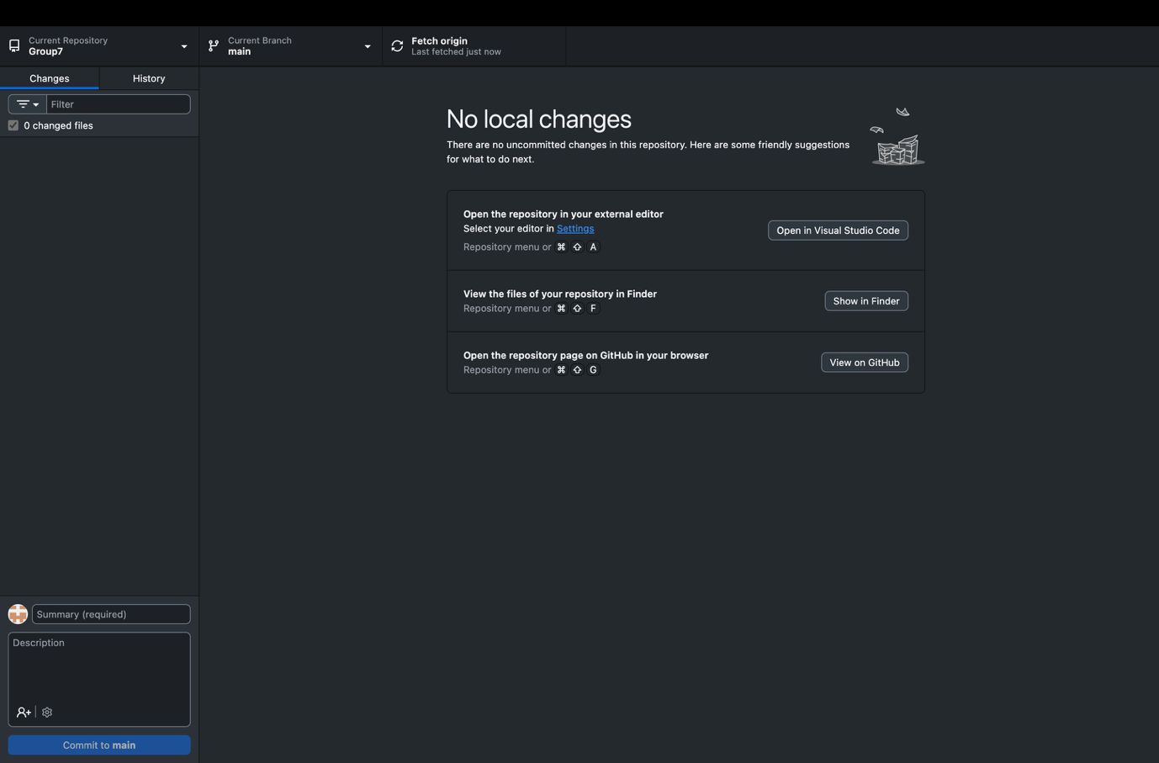

Now pulling from the source, the team grabbed fresh updates through GitHub Desktop's fetch option. Staying current means their local copy matches what's live out there.

6. Committing and Updating the Repository (2 Points)

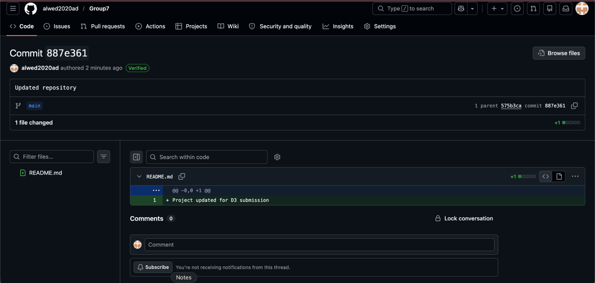

Out of nowhere, someone tweaked the README file before pushing it to the repo. Each change got recorded, just like version tracking is supposed to work. Updates appear in order - no mess, no guesswork.

Evidence for Assessment
The following may be used to support evaluation:
- GitHub repository link
- Commit history showing file updates and meaningful commit messages
- Show screeshots of the acts.

At least one commit from a non-leader group member is expected.

End of Documentation.

